STEP 1 : Go to “gloriafood.com”.

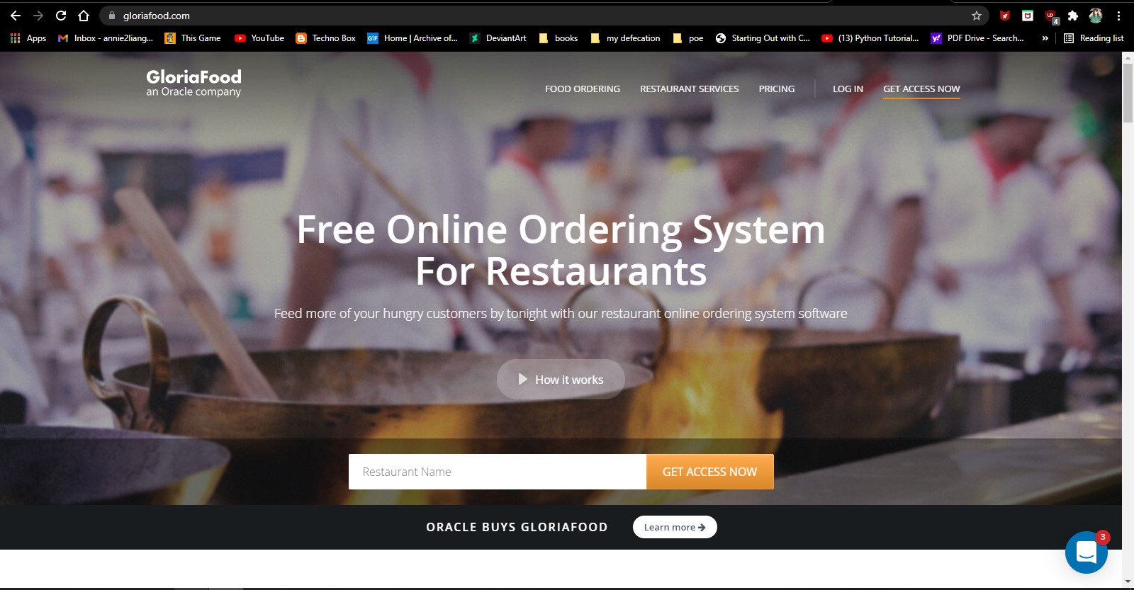

STEP 2 : Fill in your restaurant name and click “GET ACCESS NOW”.

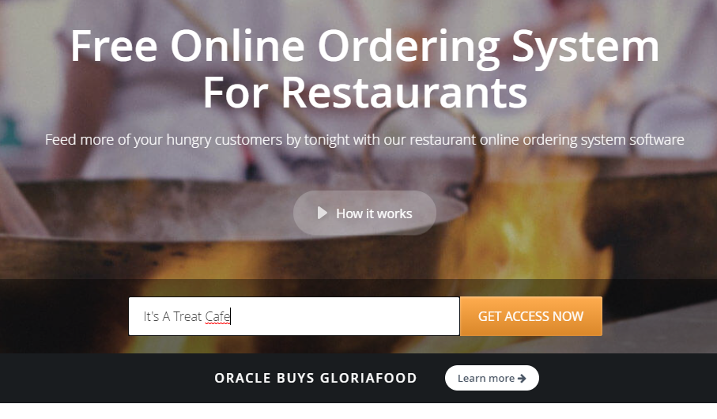

STEP 3 : Here, fill in your credentials and click continue to download the Gloriafood .zip file.

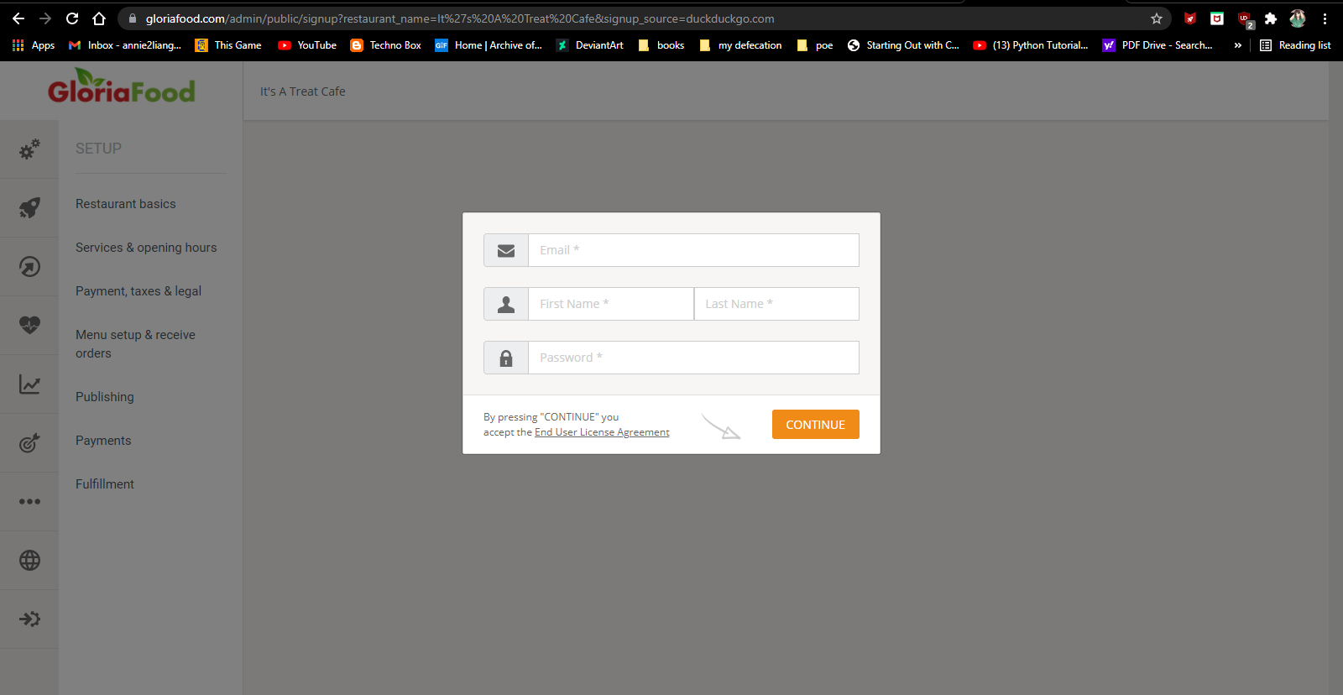

STEP 4 : Go to plugins on wordpress and click ‘add new’ to select the .zip file.

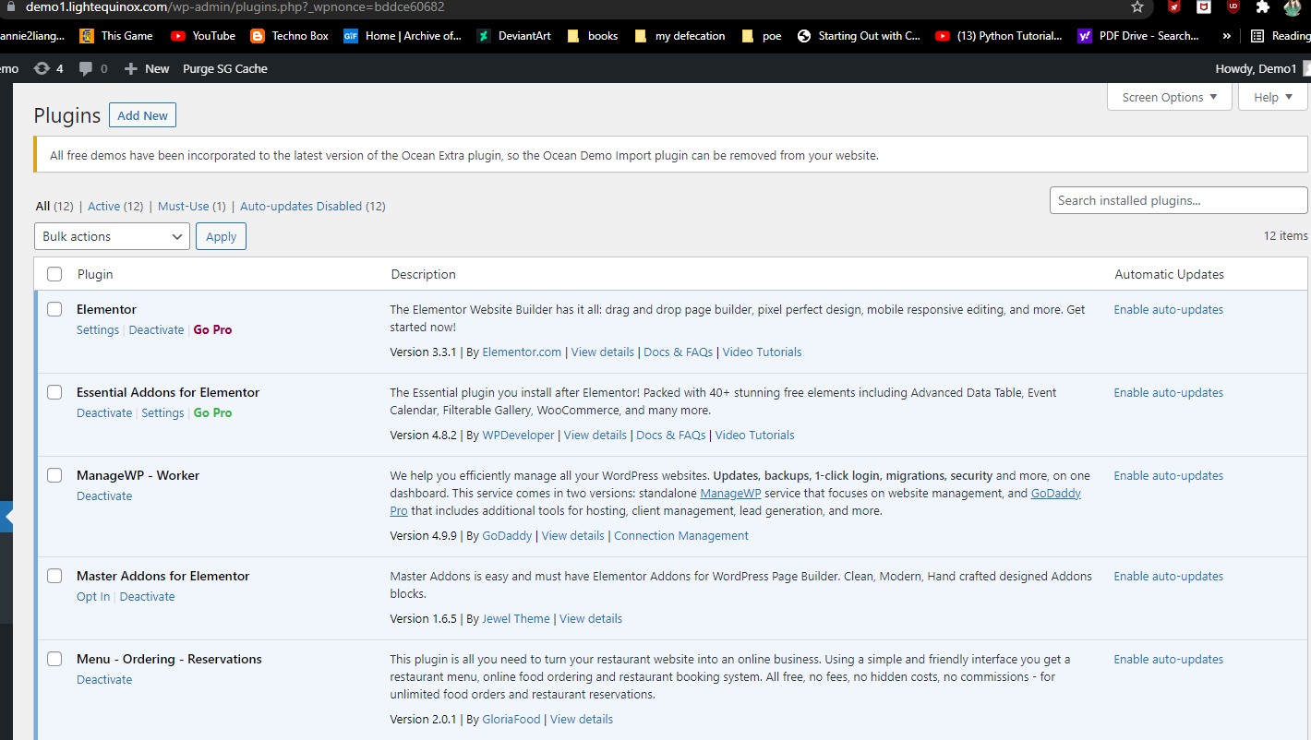

STEP 5 : Gloriafood should be in your navigation bar

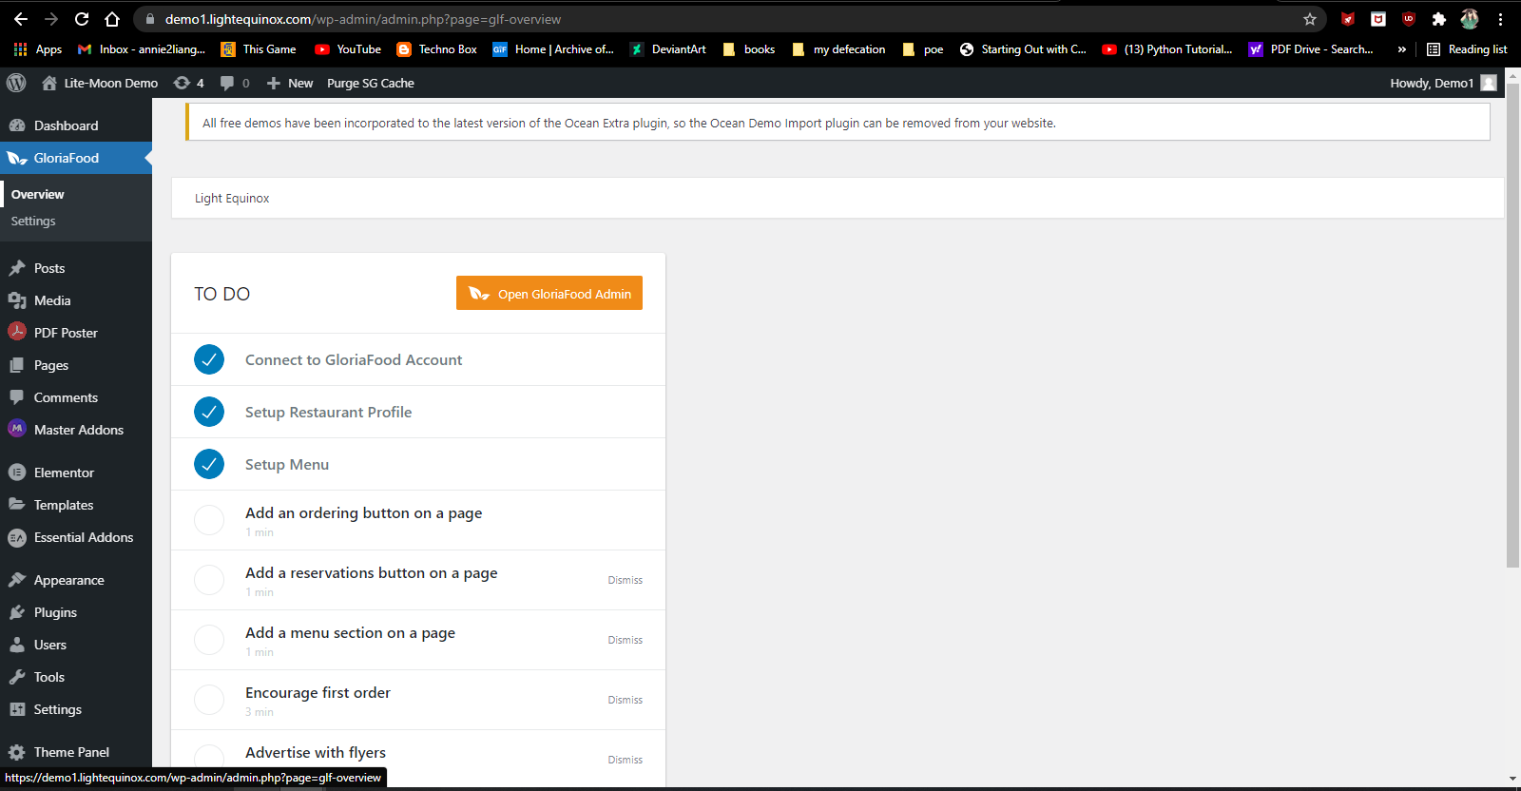

STEP 6 : Go to settings and customize the “Order Now!” button to fit your site, then “Save”.

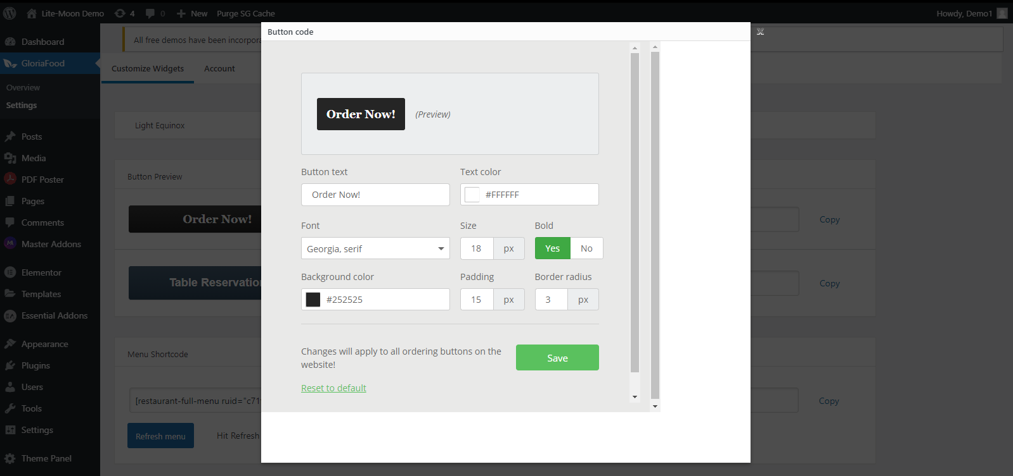

STEP 7 : Copy the shortcode.

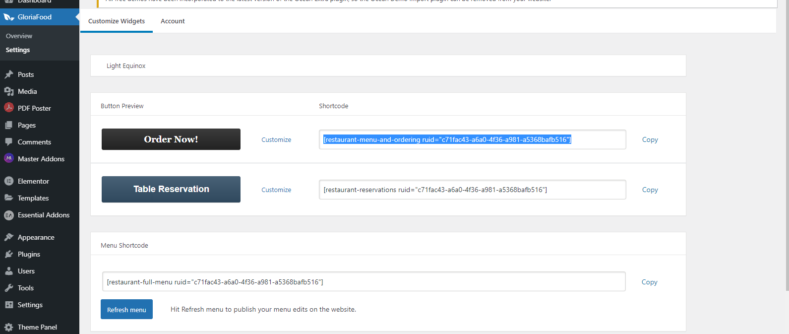

STEP 8: Go to Pages and ‘edit with elementor’

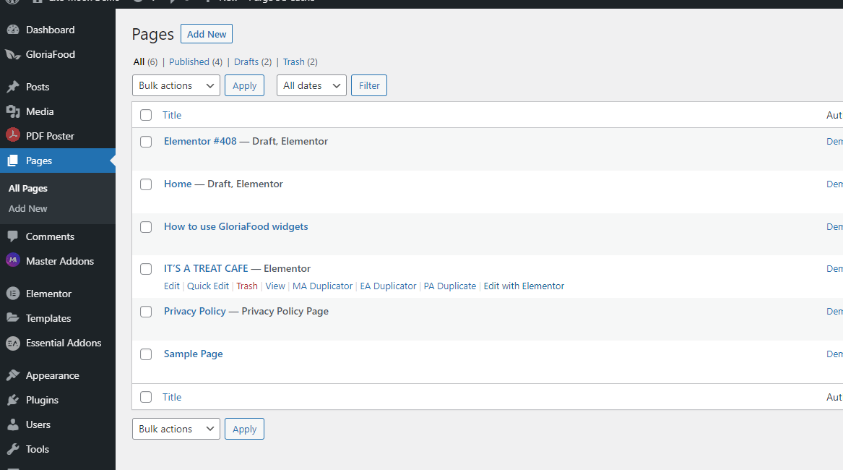

STEP 9: In the search bar, find a shortcode element and drag it in.

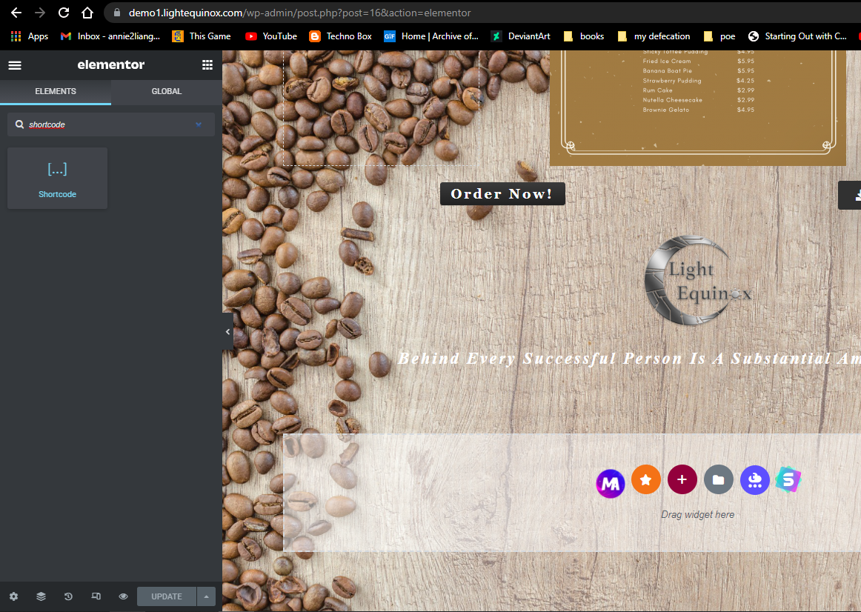

STEP 10 : Paste your shortcode in the text area and apply changes

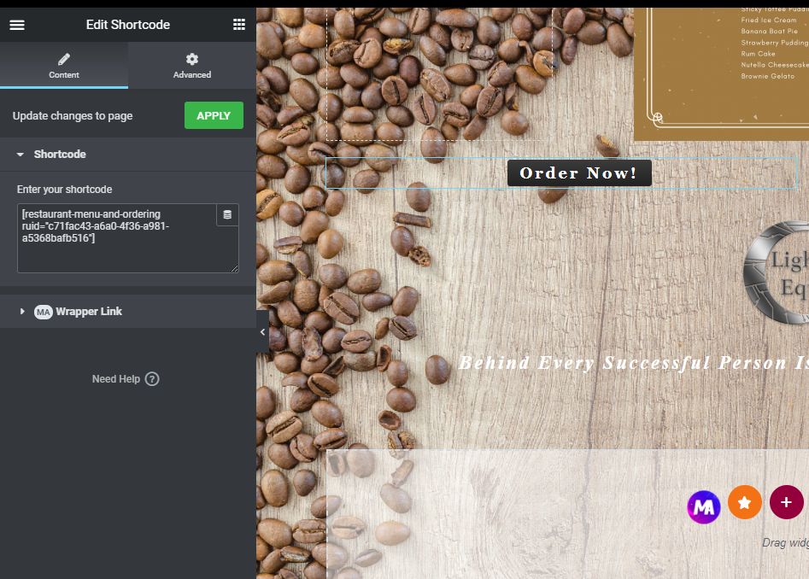

Done by: Annie Liang